CST4562 GROUP COURSEWORK / MSS LTD

MSS Ltd Network Design and Security Assessment
The proposed LAN serves 60 users across three floors. Each department has a user VLAN and a separate application server VLAN. Employees use the departmental application interfaces, a shared intranet and mail services. A dedicated backup segment separates recovery systems from employee access. The implementation uses Packet Tracer for campus traffic and isolated Linux containers for the database and vulnerability experiments.

Part I Network implementation

1 Introduction and aim
NSP Ltd is designing a LAN for MSS Ltd. Marketing occupies the first floor, Sales the second and General Support the third. The design must support existing departmental workloads, cross-department use of approved data, common services and growth. This report gives the logical and physical design, explains the equipment and cabling choices, and defines the tests for service delivery and isolation [1].

2 Requirements and assumptions
Business requirement | Design response
Marketing 20, Sales 25, Support 15 | Separate employee VLANs. Preserve all 60 workstations and label each floor and access switch.
Read data across departments | Publish each department’s data via its HTTPS application. Give employee application identities read access by policy. Restrict write privileges to department roles.
Intranet, email and Internet | Use shared services VLAN 40 for intranet and mail. Route selected egress through Router0 and the ISP simulation.
Backup and archive | Use protected VLAN 39 and a backup operator. Keep encrypted archives off the primary system and test recovery regularly.
Redundancy and growth | Provide a secondary switch path. Reserve addresses and cabinet capacity for growth and plan a second gateway as demand increases.

Design constraints
No building survey or measured cable routes were supplied. Room names and cabinet placements are proposed. The Packet Tracer Internet endpoint represents an external network. The simulated HTTP, SMTP, POP3 and FTP functions support lab demonstrations. Production services require organisational TLS trust, authenticated mail submission and encrypted backups.

3 Floor layout and cabling
Locate the main distribution frame (MDF) in a locked second-floor equipment room. Place the Marketing and General Support intermediate distribution frames (IDFs) near the vertical riser. Each floor’s outlets terminate on a labelled patch panel in its local closet. Label each cable at both ends with the floor, patch panel port and desk number.
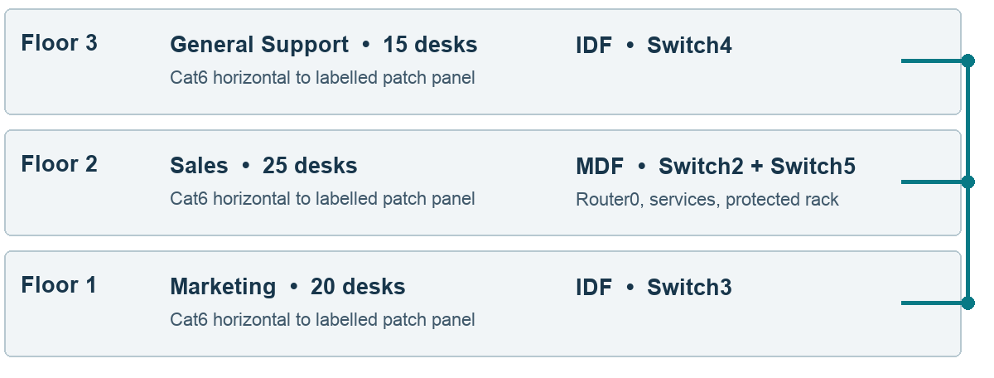
Figure 1. Proposed floor, cabinet and backbone layout. The right-hand riser represents inter-floor trunk paths.
Floor | Workstation outlets and devices | Cabinet and links
1 Marketing | M01–M20. PC13 and PC29–PC47. | IDF contains Switch3. A backbone trunk connects the IDF to the MDF.
2 Sales | S01–S25. PC11 and PC49–PC72. | Switch2 serves 23 desks. Switch5 serves PC71 and PC72 and provides the alternate trunk. Place Router0, shared services and backup equipment in the MDF.
3 General Support | G01–G15. PC14–PC28. | IDF contains Switch4. A backbone trunk runs via the first-floor aggregation point.

Media and device selection
Use Cat6 copper for desks and local equipment connections. Survey each permanent run before installation and keep it within the planned 90 m design limit. Use duplex fibre in the riser for electrical isolation and capacity. Terminate fibre in protected patch trays and select compatible optics after measuring distance. Packet Tracer uses Ethernet cables to represent these logical trunks.
The model reuses 2960 access switches and 2901 routers. Specify supported managed switches with VLAN trunks, STP and SFP uplinks for purchase. The 25-seat Sales floor needs more than one 24-port switch when uplinks and growth are allowed. The current two-switch arrangement provides usable spare capacity on Switch5 [12].

4 Logical network and address plan
Router0 routes the 802.1Q VLANs over a trunk to Switch2. Switch3 serves Marketing and connects Switch4 for General Support. Departmental server access switches terminate their server VLANs. SW-SERVICES connects the shared services and backup VLANs over a restricted trunk. The secondary path between Switch3 and Switch5 creates a loop for STP to control.
Role | VLAN and subnet | Gateway or service address
Sales users | 10 · 192.168.1.0/27 | .1 gateway
Marketing users | 20 · 192.168.1.32/27 | .34 gateway
General Support users | 30 · 192.168.1.64/27 | .66 gateway
Sales application | 12 · 192.168.1.96/30 | .98 gateway · .97 server
Marketing application | 22 · 192.168.1.100/30 | .102 gateway · .101 server
Support application | 32 · 192.168.1.104/30 | .106 gateway · .105 server
Shared services | 40 · 192.168.1.112/29 | .113 gateway · .114 intranet/DNS · .115 mail
Backup and recovery | 39 · 192.168.1.120/29 | .121 gateway · .122 backup · .123 operator
WAN transit | 192.168.1.128/27 and 192.168.1.160/27 | Router0 .151 → Router5 .152/.183 → Router1 .184
Simulated public segment | 203.0.113.0/24 | Router1 .1 · external web .10

Routing and outside connections
Router0 is the campus edge and performs port address translation on its transit interface. Router5 forwards the simulated external network to Router1, which provides the public-segment gateway. The design uses an explicit default route on Router0 and removes the prior transit default back to Router0 to avoid a forwarding loop. Internet access in the model is scoped to the external test endpoint. A real deployment would terminate its provider connection at a firewall and apply DNS and web egress policy.

VLAN and service policy
Attach inbound ACLs 110, 120 and 130 to the Sales, Marketing and Support router subinterfaces. Permit HTTPS to departmental and intranet servers, DNS to the intranet resolver, simulated SMTP and POP3 to Mail, and approved external traffic. Deny employee traffic to the backup segment and restrict other inter-VLAN paths. Exclude gateways and server addresses from DHCP allocation.

5 Implementation checks and future work
Use the implementation PKT to demonstrate addressing, routing, shared services and network policy. Use the database lab for operations that require a real SQL engine. The following matrix separates implementation checks by evidence source.
Requirement | Acceptance procedure | Evidence
Employee and application reachability | Check DHCP and gateway. Verify that a PC in each user VLAN can reach an approved departmental server. | Verified representative cross-VLAN paths from all three user VLANs.
Intranet, mail and external service | Open the intranet and simulated external web page. Send a test message between the Marketing and Sales test mailboxes and receive it at the destination. Use Router0 NAT state for troubleshooting. | HTTPS, external HTTP, SMTP submission and POP3 receipt passed.
Backup isolation | Use an employee PC to test an allowed destination and test the protected backup destination. Verify ACL hits on the relevant router interface. Use the operator PC to test the protected destination. | PC13 denied. Backup-Console passed. ACL 120 recorded hits.
Departmental data and recovery | Read synthetic records across the three schemas as the app account, attempt a prohibited write, dump the database and restore on the isolated recovery instance. | PostgreSQL 16.15. All three records matched and the unauthorized DELETE was rejected.
Redundancy | Check STP port roles. Disable the primary inter-switch link in a disposable copy, verify reconvergence and repeat a permitted traffic test. Restore the link. | Alternate port forwarded. Application server reachable with primary trunk disabled.

Packet Tracer results
PC13 received its Marketing DHCP lease, opened the HTTPS intranet and loaded the simulated external site. PC13 reached the Sales application server and was denied access to the backup server. Router0 ACL 120 counted four permits to the Sales server and four denies to the backup segment. Backup-Console received 4/4 replies from the backup server. A Marketing-to-Sales message passed SMTP submission and POP3 receipt. In the link-failure exercise, Switch3 Fa0/24 changed from alternate blocking to root forwarding and PC13 received 3/4 replies from the Sales server with the primary link disabled. After restoration, the primary port returned to Root FWD and the alternate to Altn BLK. General Support reached Sales with 4/4 replies. Sales reached Marketing with 3/4, with the first request timing out. The evidence file records the test conditions and results. The PostgreSQL retest output appears in the test execution evidence. Appendix C shows the Packet Tracer retest.

Future proposition and conclusion
Add a second gateway and independent edge path when the availability target justifies their cost. Allocate a larger user subnet or an additional VLAN before Sales exhausts its /27. Place the shared services behind a firewall or equivalent layer-3 policy, add central log collection and use a separate identity service. Set recovery objectives with the business and verify them through a timed restore exercise.
The design gives the departments scoped access to shared data and puts recovery systems behind a separate access boundary. The existing switches and routers serve as simulation models for the addressing, trunk and routing choices.

Part II Vulnerability analysis
An isolated assessment reproduced three plausible failure modes for the MSS Ltd LAN: direct employee reachability of a backup database listener, exposure of a reusable intranet token over HTTP, and execution of an administrative export by an employee account. The lab retest blocked all three paths while preserving the employee directory, administrator export and backup listener for their intended clients.

6 Scope and network risks
MSS Ltd requires Marketing, Sales and General Support staff to access departmental data, intranet and email. The baseline Packet Tracer model labels three user VLANs and separate departmental server VLANs [1]. A VLAN boundary separates broadcast domains. The inter-VLAN policy still determines which services an employee can reach.
Department | User network | Department server network
Marketing | VLAN 20 · 192.168.1.32/27 | VLAN 22 · 192.168.1.100/30
Sales | VLAN 10 · 192.168.1.0/27 | VLAN 12 · 192.168.1.96/30
General Support | VLAN 30 · 192.168.1.64/27 | VLAN 32 · 192.168.1.104/30
On Router0, the Marketing gateway (Gi0/0.20, 192.168.1.34/27) showed no inbound or outbound ACL. A Marketing PC reached the Sales server by ICMP (3 of 4 replies). This establishes a routed path for the allowlist test. TCP permissions require their own checks from all three departments. The baseline model showed three departmental servers. It had no separately labelled intranet, mail or backup server in the inspected logical view (PT-main-topology.txt).

Assessment boundaries
The experiment used two internal Docker bridges and synthetic identities and data. The Kali employee client and intranet shared 172.29.216.0/24. The PostgreSQL backup fixture had a protected address on 172.29.217.0/24 and an additional employee-facing address in the baseline. No lab ports were published. The two bridges approximate trust zones. Packet Tracer supplied the LAN design context [1–3].
The findings below establish what happened in the Docker model. Deployment validation requires checking the actual VLAN ACLs, application roles and encryption settings. SMTP, Internet ingress, wireless, device management, real backup data and restore performance were outside the experiment.

Risk ranking
High priority means the model demonstrates sensitive data or credentials crossing a trust boundary under plausible internal conditions. Medium means the model demonstrates reachable attack surface and a further authentication or software failure would be needed to access backup data.

7 Tools and test results
Kali Linux supplied Nmap 7.991, curl 8.22.0 and tcpdump 4.99.6. PostgreSQL 16.15 represented the backup database. The same employee-side address (172.29.216.10) was used for both phases. E00 and E04 record the network attachment and published-port state. See the test execution evidence for rerun output and Figures 2 and 3 for packet captures.

VA1 Backup database exposure | Medium
Use Nmap TCP connect scanning to verify allowed and disallowed flows from the employee perspective. Service detection helps identify a listener for follow-up [4].
nmap -sT -sV --version-light -Pn -n --reason -p 5432 172.29.216.20
nmap -sT -sV --version-light -Pn -n --reason -p 8080,8443 172.29.216.30
TCP/5432 was open on the employee-facing backup address (E01). An employee could establish a TCP connection to the database listener and attempt authentication or probe for a service weakness. The test stopped at service reachability. After removal of the employee-facing attachment, Nmap reported TCP/5432 as filtered from the employee side at both the retired and protected addresses. The protected-side control scan still showed 5432 open at 172.29.217.20 (E05).

VA2 Cleartext intranet session token | High
Capture the employee client’s own traffic on eth0 and read the packet payloads with tcpdump [5]. Compare successful application requests in both phases. This models exposure to a party already able to observe the connection.
tcpdump --immediate-mode -p -i eth0 -U -s0 -w /tmp/capture.pcap "host 172.29.216.30 and tcp"
tcpdump -nn -A -r /tmp/capture.pcap
The baseline capture exposed the Authorization header in readable form (E03). A party on the traffic path could reuse the bearer token while valid. After the move to HTTPS, the directory still responded with 200. The packet capture no longer showed the cleartext marker, curl negotiated TLSv1.3 and a hostname mismatch failed certificate verification with exit code 60 (E06–E08) [6]. TCP/8080 changed from open to closed and 8443 became open (E01, E05).

VA3 Employee access to an administrator export | High
Use curl with anonymous, employee and administrator identities on the same export route. Compare access to the employee directory as a control. This tests vertical privilege escalation [7].
curl --cacert /tmp/lab-ca.pem --resolve intranet.lab:8443:172.29.216.30 \
-H "Authorization: Bearer LAB-EMPLOYEE-ONLY" \
https://intranet.lab:8443/admin/export
The employee received HTTP 200 and a synthetic export in the baseline. After a server-side role check, the same employee received 403. The unauthenticated request remained 401, while the employee directory and the administrator export both returned 200 (E02, E06). This confirmed unauthorized reading of the export in the baseline.

Test execution evidence
2026-11-09 09:11:08 UTC. Kali, the intranet and PostgreSQL ran on internal Docker networks with synthetic data. The following excerpts preserve the recorded command output.

VA1 Nmap backup listener
$ docker exec cst4562-59422-kali nmap -sT -sV --version-light -Pn -n --reason \
-p 5432 172.29.216.20
PORT STATE SERVICE REASON VERSION
5432/tcp open postgresql syn-ack PostgreSQL DB
After the employee-facing database interface was detached:
$ docker exec cst4562-59422-kali nmap -sT -sV --version-light -Pn -n --reason \
-p 5432 172.29.217.20
PORT STATE SERVICE REASON VERSION
5432/tcp filtered postgresql net-unreach
Positive control from backup network
PORT STATE SERVICE REASON
5432/tcp open postgresql syn-ack

VA3 curl employee export
Baseline request to http://intranet.lab:8080/admin/export
{"export": ["MSS-LAB-SYNTHETIC-RECORD"]}
HTTP 200
Hardened request to https://intranet.lab:8443/admin/export
{"error": "administrator role required"}
HTTP 403

VA2 tcpdump and TLS verification
Baseline HTTP payload excerpt (E03)
Authorization: Bearer LAB-EMPLOYEE-ONLY
Hardened HTTPS verification excerpt (E08)
* SSL connection using TLSv1.3 / TLS_AES_256_GCM_SHA384 / x25519 / RSASSA-PSS
* SSL certificate verified via OpenSSL.

PostgreSQL write and recovery retest
Application identity write denied
ERROR: permission denied for table quote
Restored in isolated backup network
Example campaign
Example quote
Example ticket
PASS: three department records restored and matched

Wireshark packet capture comparison
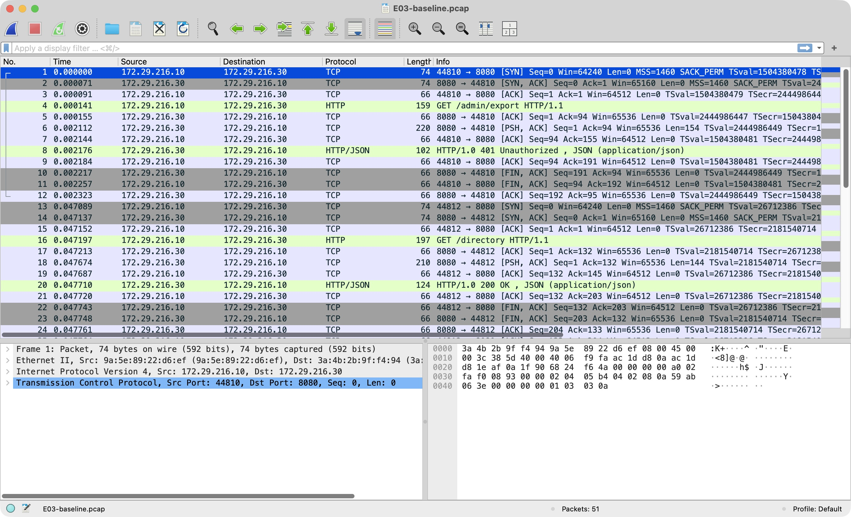
Figure 2. Baseline HTTP requests on TCP/8080 in E03-baseline.pcap. The packet list shows the request paths and response codes.
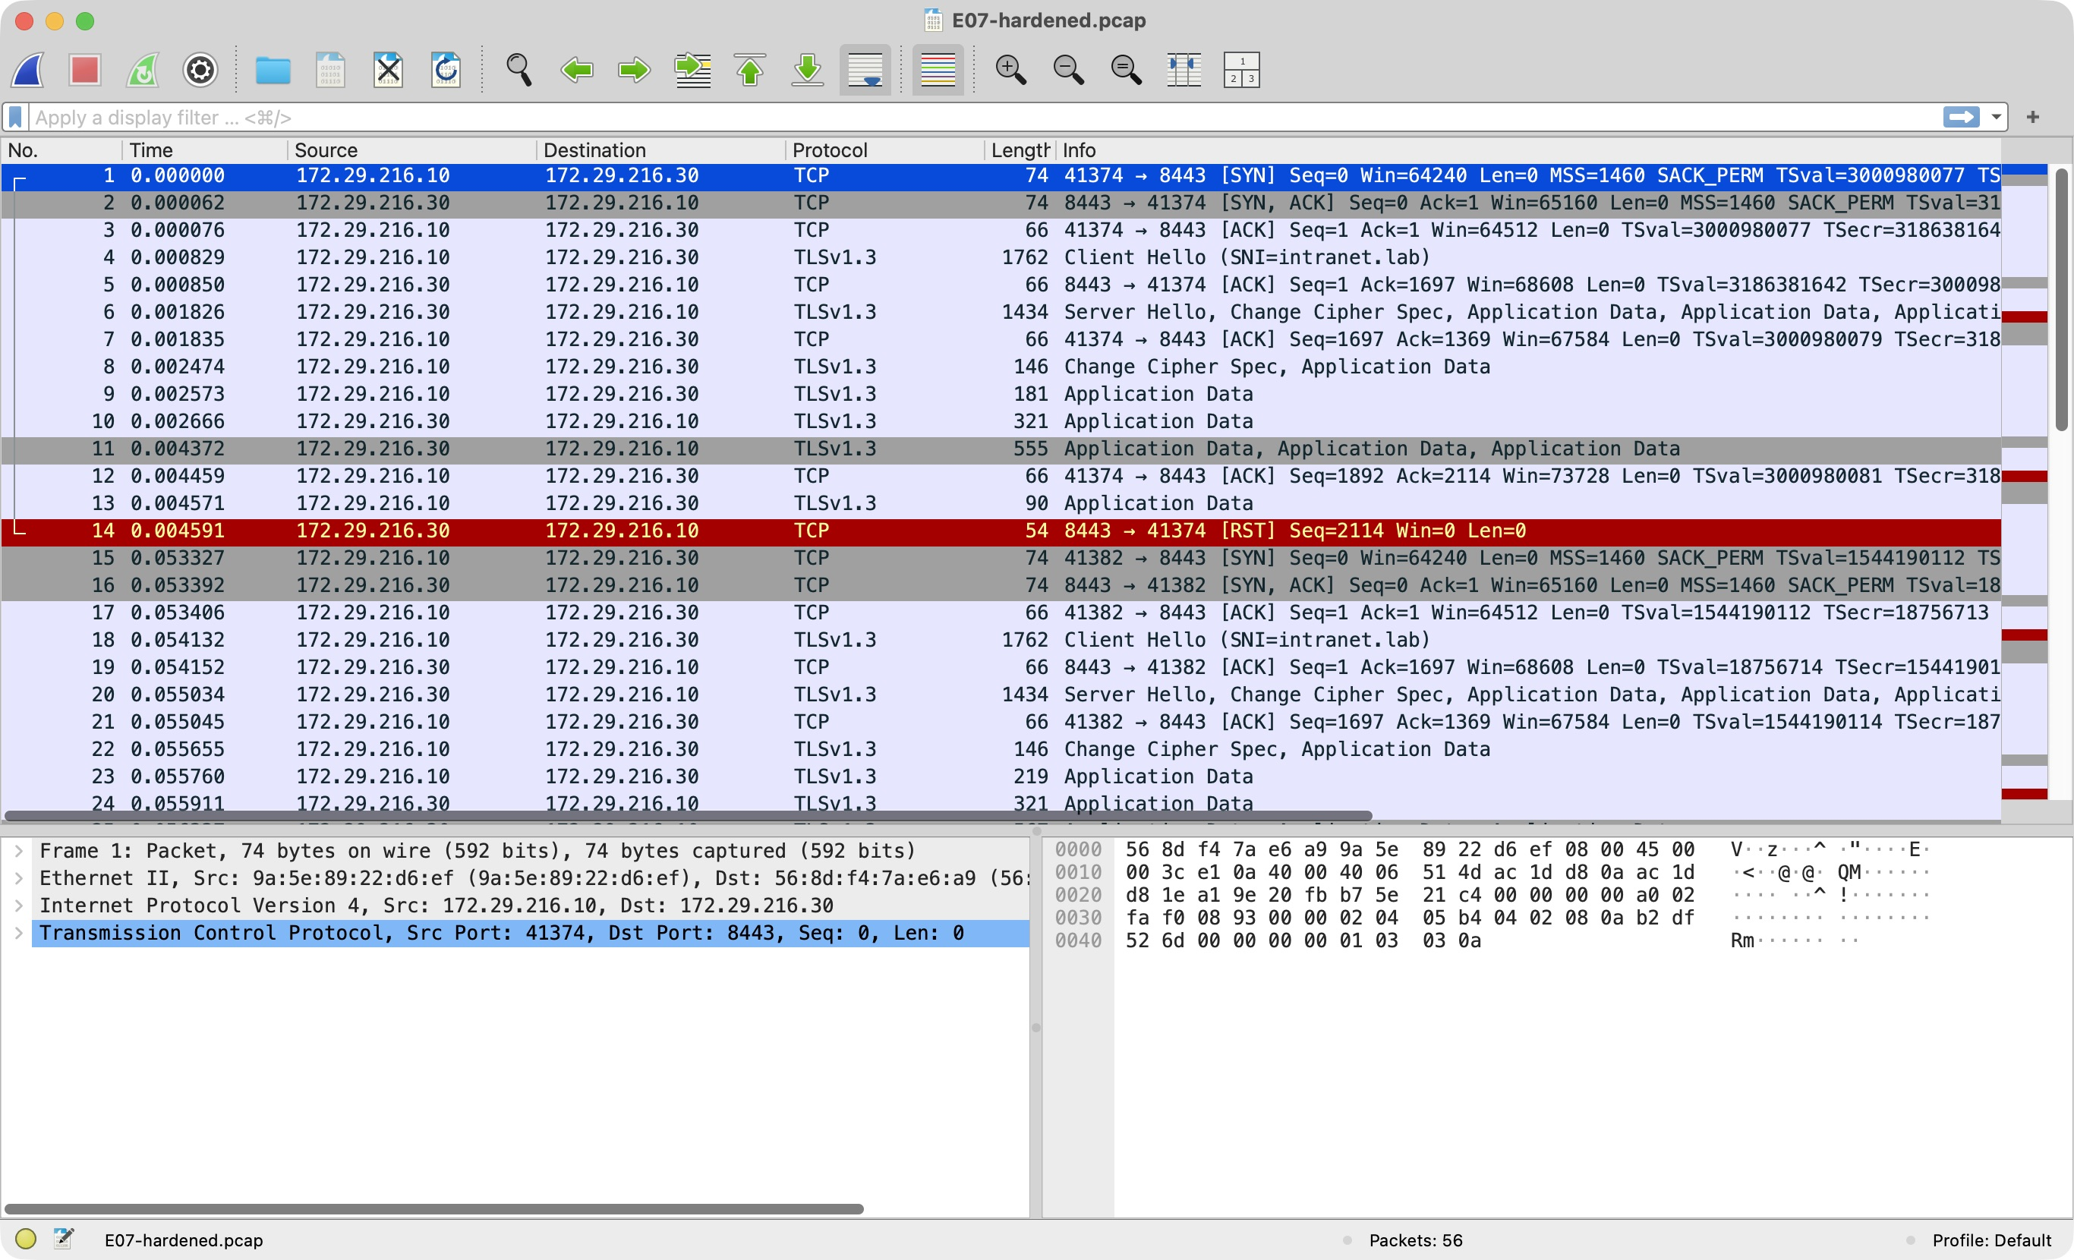
Figure 3. Hardened HTTPS traffic on TCP/8443 in E07-hardened.pcap. Wireshark shows the TLS 1.3 handshake and encrypted application data.

8 Defences and acceptance criteria
Apply the application and transport fixes before releasing the intranet. Restrict the backup path before placing any production data on it. Test denied paths together with legitimate service flows so a general outage cannot be mistaken for effective enforcement.
Finding and owner | Production control | Acceptance check
VA1  Network and database teams | Put backup services in a dedicated zone. Allow only identified backup or recovery hosts to reach the actual backup protocol. Restrict database listeners and enforce source, account and database rules on the server [8]. | From each user VLAN, backup TCP must be unreachable. From the backup controller, verify permitted access and a successful backup. Record ACL counters and database auth logs.
VA2  Infrastructure team | Serve intranet logins and sessions only over HTTPS using an organisation-trusted certificate and validated names. Reject plaintext requests carrying credentials, rotate exposed tokens and monitor expiry. | From all three user VLANs, verify valid HTTPS and rejection of invalid names or trust. Capture only synthetic test traffic and verify that credentials are absent from readable payloads.
VA3  Application owner | Enforce default-deny role checks on the export endpoint and scope departmental data access at the record layer. Audit privileged exports with identity, outcome and timestamp. | Expect anonymous 401, employee export 403, employee directory 200 and administrator export 200. Add cross-department record tests using the agreed business permission matrix.

Preserving legitimate access
Apply the employee-facing allowlist at the inter-VLAN policy boundary and verify rule attachment and counters on each routed path. Permit HTTPS to the intranet and approved departmental applications, plus the required DNS, email and Internet egress paths. Departmental applications can then query their required databases with scoped service accounts. The backup policy should permit only the replication, backup and recovery flows named by their owners. Keep privileged device management on a separate admin path and review denials after changes.

Evidence and reproducibility
The companion vulnerability-lab folder contains run.sh, the synthetic application and the raw outputs. E00/E04 document scope, E01/E05 contain Nmap results, E02/E06 contain the request outcomes, E03/E07 contain packet captures and decoded output, and E08 records certificate verification. The runner tests the expected states and writes verification.txt on success.
The tested segment change detached one network interface. MSS Ltd would implement the equivalent policy using routing and ACLs or a firewall. The model did not measure firewall throughput, redundant gateway behaviour or production restore success.

9 Security maintenance
The proposed schedule assigns checks to service owners. Store test results against the asset inventory and link every deviation to a change or remediation ticket. Use an authorised test window for active scans, stage updates and verify the installed version and affected business flows after deployment [2,9].
Cadence and owner | Check and evidence | Action threshold
Daily  Operations | Review backup job status, denied inter-VLAN flows, administrative exports and certificate expiry alerts. | Investigate a failed backup, unexpected export or new employee-to-backup connection.
Weekly  Network team | Run scoped Nmap scans from one approved test point per user VLAN. Compare exposed services with the approved inventory. | Investigate any new listener or changed reachability before accepting it as baseline.
Monthly and after relevant changes  Service owners | Review vendor advisories against inventory. Repeat positive and negative tests for backup access, intranet TLS and application roles. | Escalate any failed security or business-flow control. Recheck and attach evidence before closing.
Quarterly  Backup and security teams | Restore a representative backup in isolation. Measure restore time and recovered data against agreed recovery objectives. Review ACL exceptions and administrator roles. | Record missed recovery targets and remove expired access exceptions through change control.

References
[1] Middlesex University Dubai, CST4562 Coursework Brief, pp. 19–22. Project artefact, CW_CST4562.pkt.
[2] NIST SP 800-115, Technical Guide to Information Security Testing and Assessment.
[3] Docker, Network Create Reference.
[4] Nmap Project, Nmap Reference Guide.
[5] The Tcpdump Group, tcpdump Manual.
[6] curl Project, TLS Certificate Verification.
[7] OWASP WSTG v4.2, Testing for Bypassing Authorization Schema.
[8] PostgreSQL 16 Documentation, The pg_hba.conf File.
[9] NIST SP 800-40 Rev. 4, Guide to Enterprise Patch Management Planning.
[10] Cisco Networking Academy, Packet Tracer Web and Email Servers.
[11] PostgreSQL 16, SQL Dump.
[12] Cisco, Campus LAN and Wireless LAN Solution Design Guide.

Appendix A Evidence index
Evidence set | What it supports
PT-main-topology.txt | Baseline VLAN and ACL observations.
PT-optimized-retest.txt | Layout preservation and baseline inter-VLAN ICMP tests.
Vulnerability lab E00–E08 | Network scope, Nmap service exposure, HTTP and TLS packet captures, and application authorisation.
database-verification.txt | Scoped read privileges and restoration of records from all three schemas.
PT-implementation-verification.txt | Packet Tracer observations and acceptance results.

Appendix B Group activity list
Group member | Student ID | Contribution
Zhijie Xie | M01141159 | Wrote the vulnerability analysis report.
John Ashis Roy | M00889075 | Designed the network and prepared the Packet Tracer topology.
Gul Khalid Khan I | M01144661 | Prepared the coursework presentation slides.
Boon Suni | M01155019 | Reviewed the floor layout, cabling rationale and address plan.
Adam Peter | M01156859 | Performed service acceptance checks, reviewed evidence and integrated the final report.

Appendix C Packet Tracer acceptance tests
The screenshots show tests run in the coursework simulation. The email retest used the synthetic Marketing and Sales mailboxes and the Mail server at 192.168.1.115.
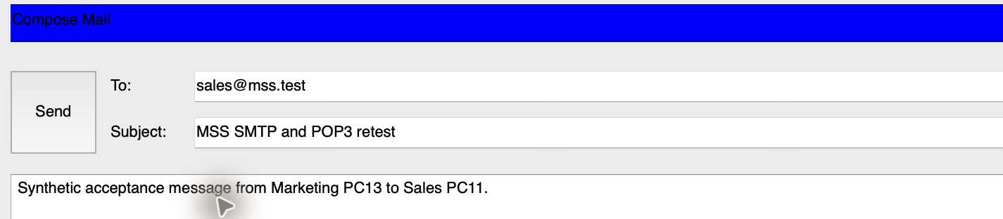
Figure 4. PC13 prepares the message MSS SMTP and POP3 retest for sales@mss.test.
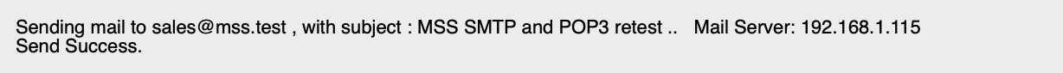
Figure 5. PC13 reports Send Success after SMTP submission to 192.168.1.115.
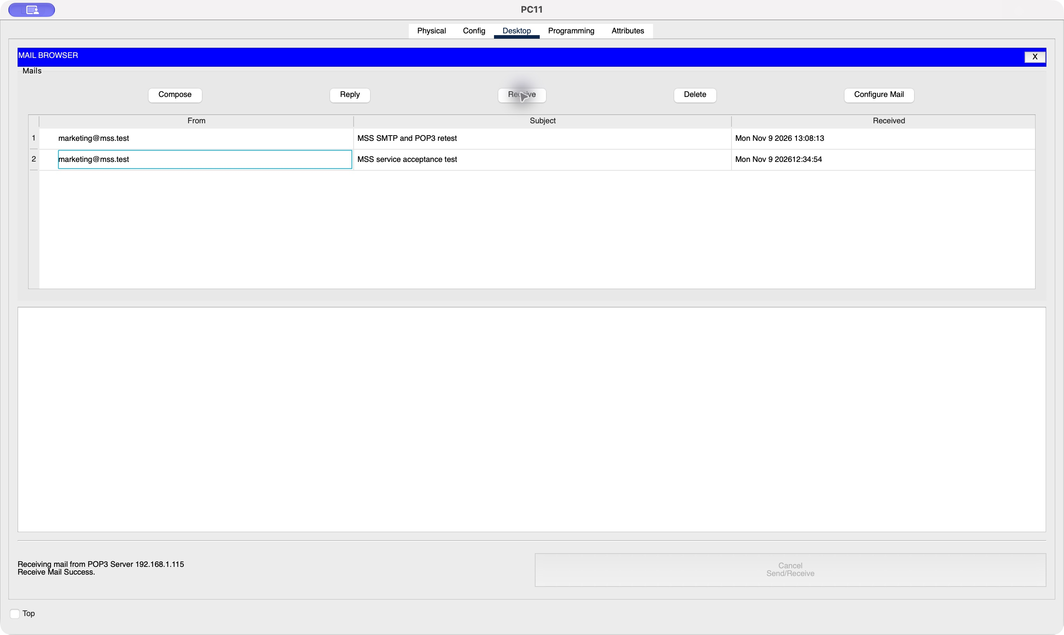
Figure 6. PC11 retrieves the matching test message. The upper crop shows the inbox and the lower crop shows the POP3 success status.

Addressing and web access
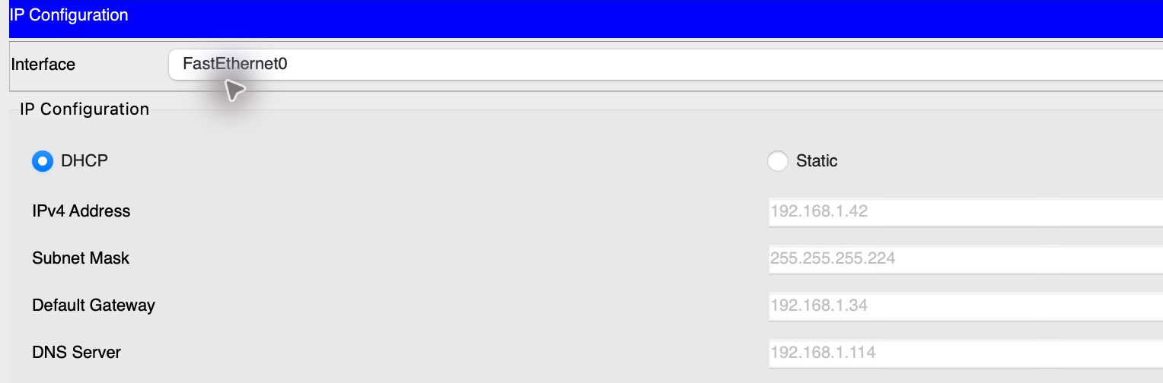
Figure 7. PC13 received 192.168.1.42/27 in the retest, with gateway 192.168.1.34 and DNS 192.168.1.114.
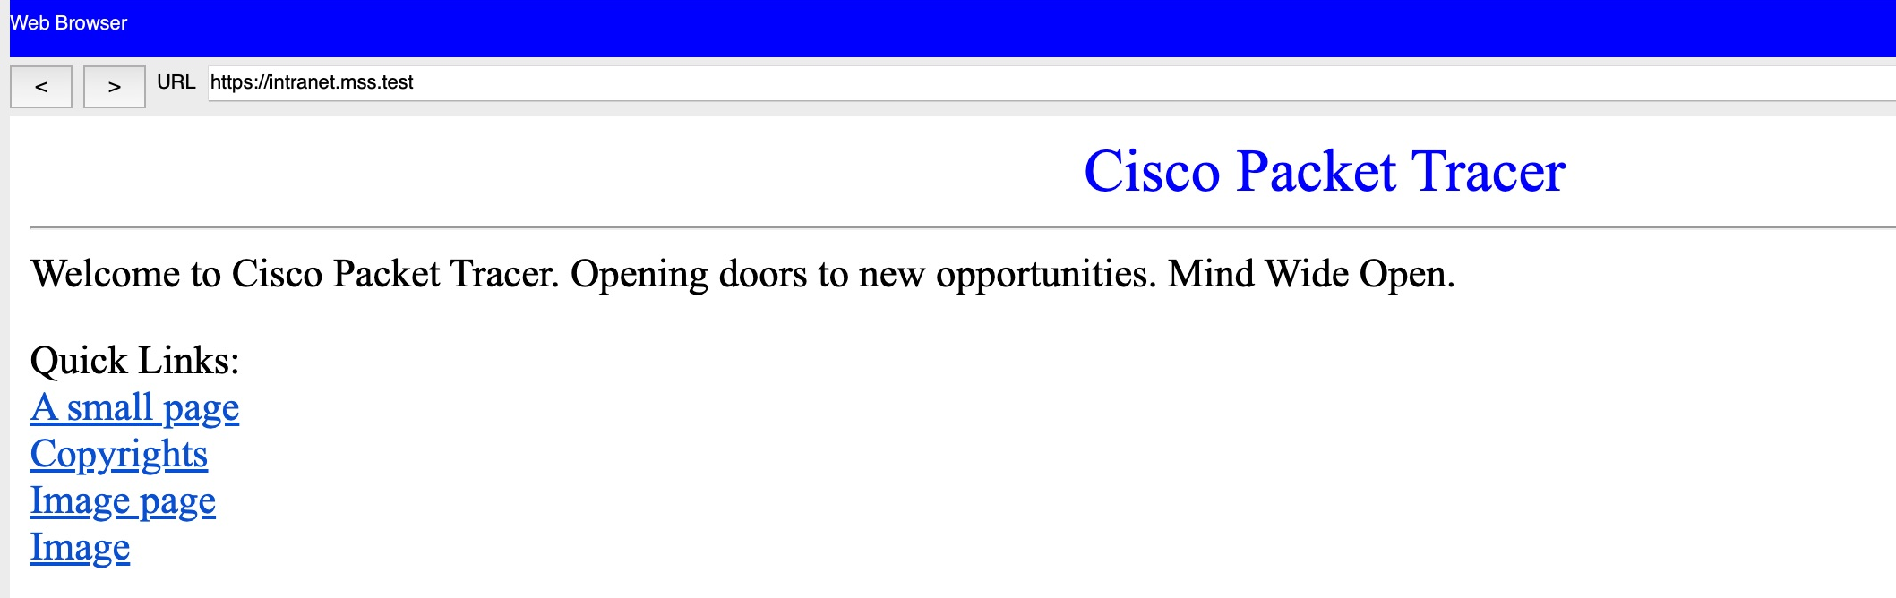
Figure 8. PC13 loads the intranet at https://intranet.mss.test.
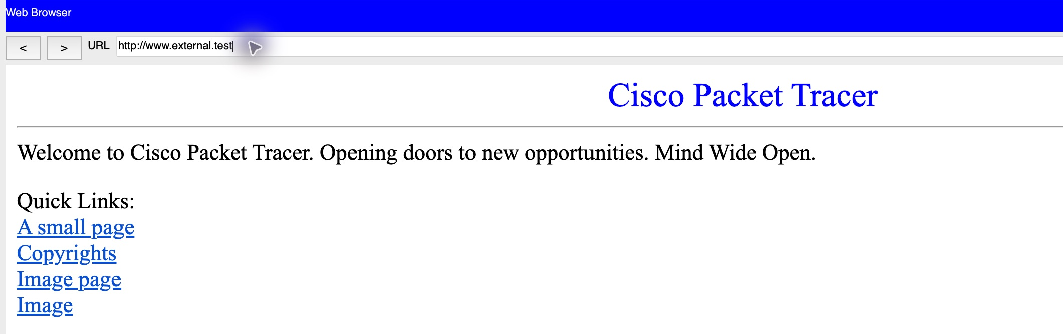
Figure 9. PC13 loads the simulated external website at http://www.external.test.

VLAN reachability and backup isolation
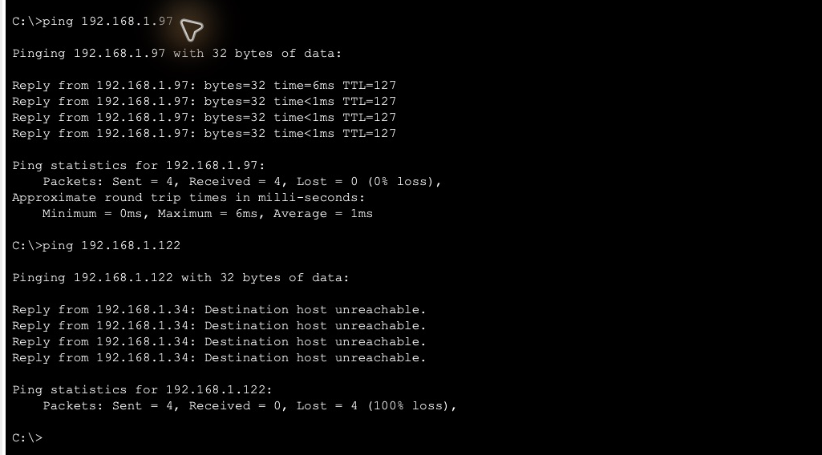
Figure 10. Marketing PC13 reaches the Sales server at 192.168.1.97 with 4/4 replies. Its gateway rejects all four attempts to reach the backup server at 192.168.1.122.
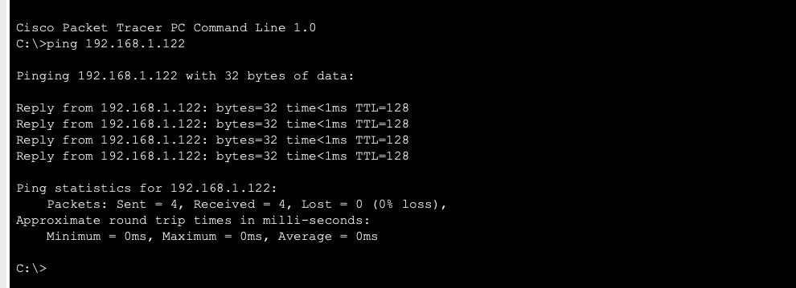
Figure 11. Backup-Console reaches 192.168.1.122 with 4/4 replies. This verifies that the service segment remains reachable from the permitted side.

Router access rules and spanning tree
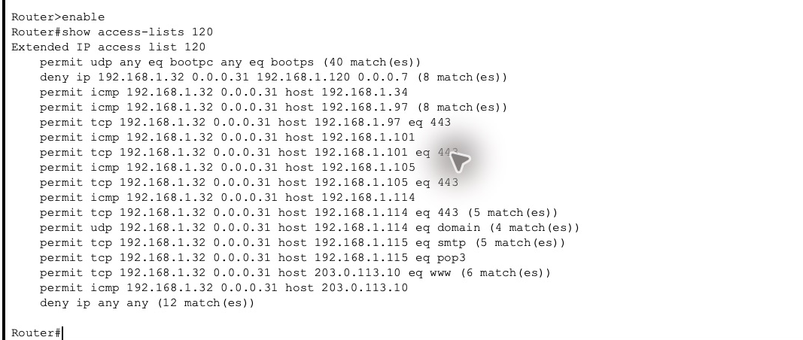
Figure 12. Router0 show access-lists 120 shows matches on the backup subnet deny rule and on the ICMP permit rule for the Sales server.
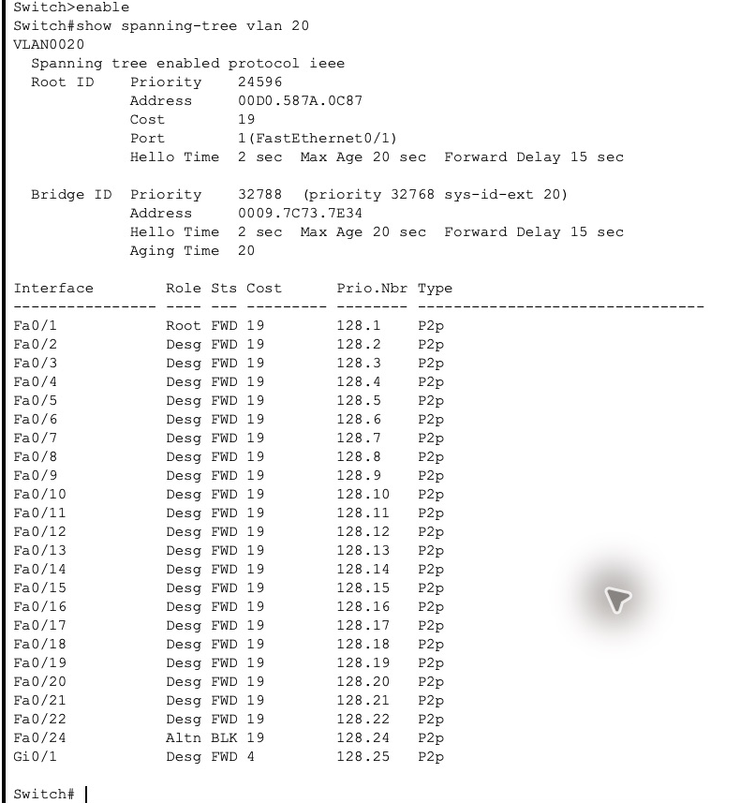
Figure 13. Switch3 VLAN 20 shows the normal link roles. Fa0/1 is Root FWD and Fa0/24 is Altn BLK. The earlier failover test is recorded in PT-implementation-verification.txt.

